Suma

M = ({q0, q1, q2, q3, q4}, {1, +, =}, {1, +, =, B}, δ, q0, {q4})

|  |  |  |  |  |  |
| --- | --- | --- | --- | --- | --- |
|  | 1 | + | = | B | x |
| q0 | (q1, x, R) | (q0, +, R) | (q4, =, R) |  |  |
| q1 | (q1, 1, R) | (q1, +, R) | (q2, =, R) | (q2, =, R) |  |
| q2 | (q2, 1, R) |  |  | (q2, 1, R) |  |
| q3 | (q3, 1, L) | (q3, +, L) | (q3, =, L) |  | (q0, 1, R) |
| q4 | - | - | - | - |  |

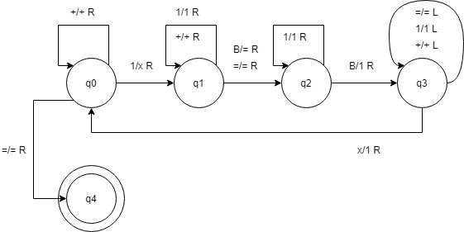

Resta

M = ({q0, q1, q2, q3, q4, q5, q6, q7, q8}, {1, -, =},

{1, -, =, X, B}, δ, q0, {q8})

|  |  |  |  |  |  |  |
| --- | --- | --- | --- | --- | --- | --- |
|  | 1 | - | = | X | B | Y |
| q0 | (q1, X, R) | (q4, -, R) |  |  |  |  |
| q1 | (q1, 1, R) | (q1, -, R) | (q2, =, R) |  | (q2, =, R) |  |
| q2 | (q2, 1, R) |  |  |  | (q3, 1, R) |  |
| q3 | (q3, 1, L) | (q3, -, L) | (q3, =, L) | (q0, 1, R) |  |  |
| q4 | (q5, Y, R) |  | (q8, =, R) |  |  |  |
| q5 | (q5, 1, R) |  | (q5, =, R) |  | (q6, B, L) |  |
| q6 | (q6,B, L) |  |  |  |  |  |
| q7 | (q7, 1, L) |  | (q7, =, L) |  |  | (q4, 1, R) |
| q8 | - | - | - | - | - | - |

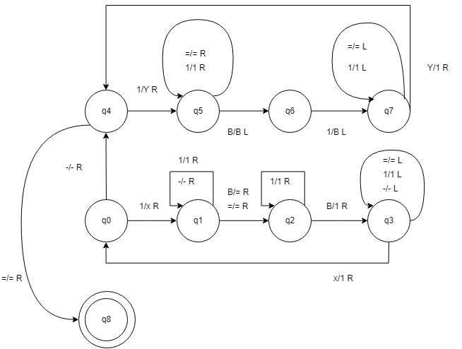

Copiar Patrón

M = ({q0, q1, q2, q3, q4, q5, q6, q7, q8, q9, q10}, {a, b, c}, {a, b, c, X, Y, Z, B}, δ, q0, {q10})

|  |  |  |  |  |  |  |  |  |
| --- | --- | --- | --- | --- | --- | --- | --- | --- |
|  | a | b | c | = | X | Y | z | B |
| q0 | (q1, X, R) | (q2, Y, R) | (q3, Z, R) | (q10, =, L) |  |  |  |  |
| q1 | (q1, a, R) | (q1, b, R) | (q1, c, R) |  |  |  |  |  |
| q2 | (q2, a, R) | (q2,b,R) | (q2, c, R) | (q6, =, R) |  |  |  | (q6, =, R) |
| q3 | (q3,a, R) | (q3,b, R) | (q3,c, R) | (q8,=, R) |  |  |  | (q8,=, R) |
| q4 | (q4, a, R) | (q4, b, R) | (q4, c, R) |  |  |  |  | (q5,a, L) |
| q5 | (q5, a, L) | (q5, b, L) | (q5, c, L) |  | (q0, a, R) |  |  |  |
| q6 | (q6, a, R) | (q6, b, R) | (q6, c, L) |  |  |  |  | (q7,b, R) |
| q7 | (q7, a, L) | (q7, b, L) | (q7, c, L) |  |  | (q0, b, R) |  |  |
| q8 | (q8, a, R) | (q8, b, R) | (q8, c, R) |  |  |  |  | (q9, c, R) |
| q9 | (q9, a, L) | (q9, b, L) | (q9, c, L) |  |  |  | (q0, c, r) |  |
| q10 | - | - | - |  | - | - | - |  |

